Final Project Part 1
Part 1: Database Design
- Design an ER diagram covering at minimum:
  - Customers: name, email, region.
  - Products: name, category, price, and the SKU used by the source systems.
  - Reviews: customer, product, rating, comment, date.
- Normalize to third normal form. Two dependencies worth checking: a customer's region determines their country, and a product's category repeats across rows—state which normal form your tables reach.
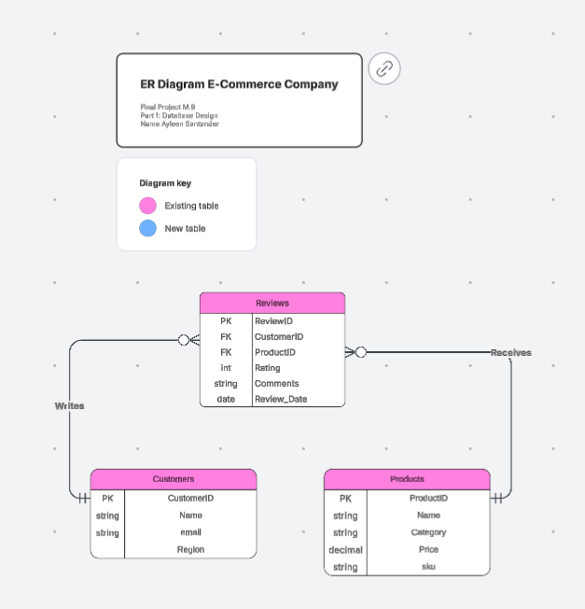
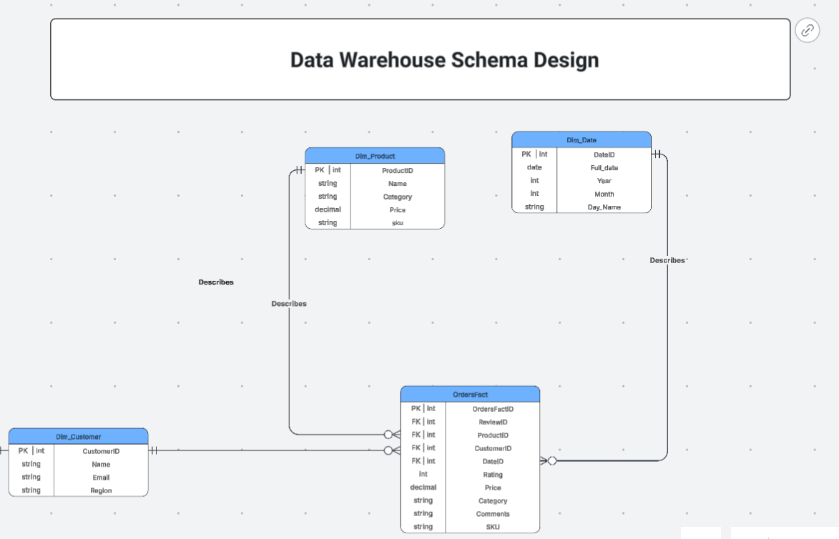
- Define primary keys, foreign keys with explicit ON DELETE actions, and CHECK constraints on bounded columns such as the rating.
Decide whether the review-to-customer link may be NULL. Some reviews in the data cannot be matched to a known customer. Justify whichever way you go.
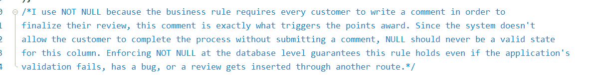
- Add a constraint that makes re-running an import safe. The three feeds issue their own record IDs, and those IDs can collide across sources.
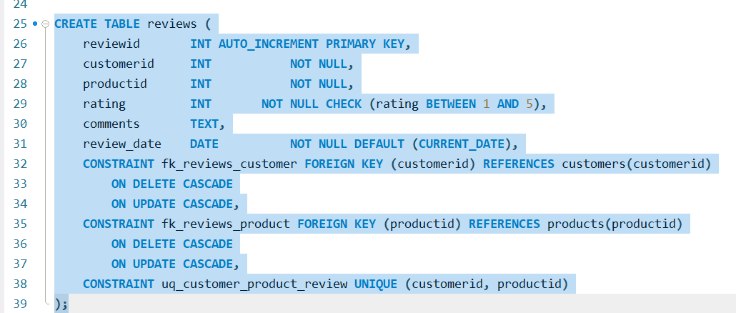
- Implement it in MySQL as a single script that drops and recreates the database from scratch.
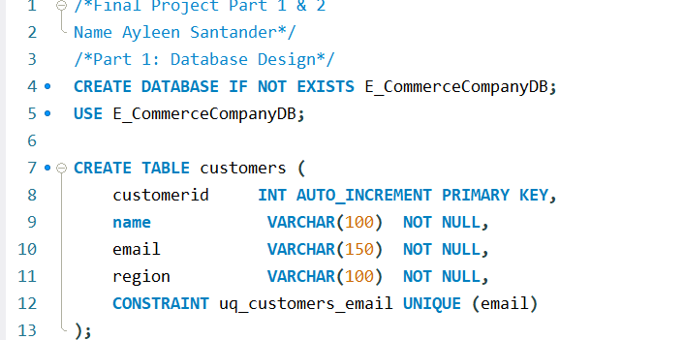
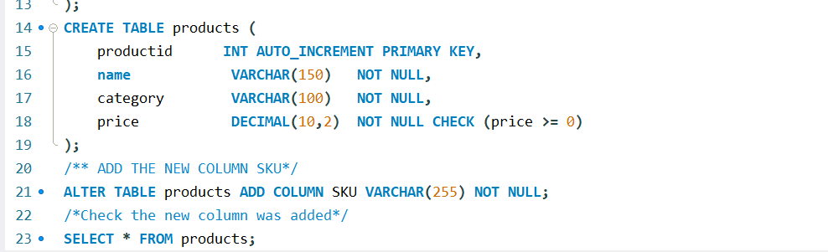
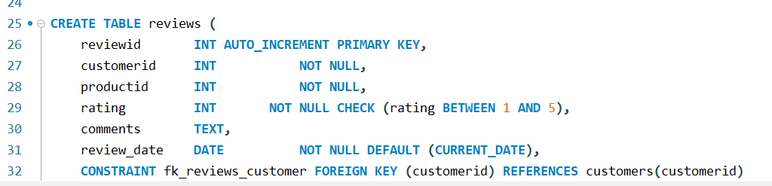
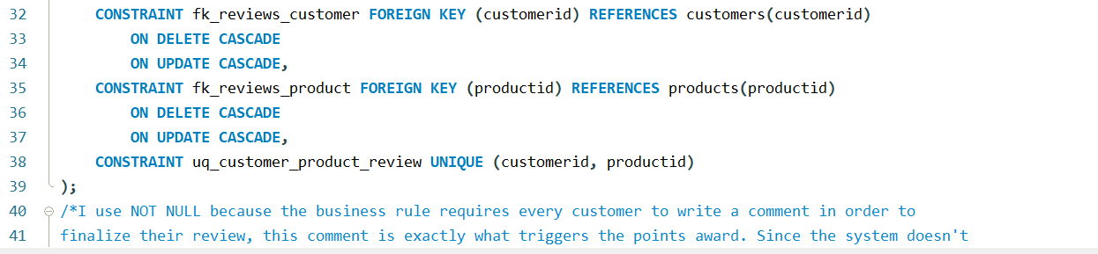

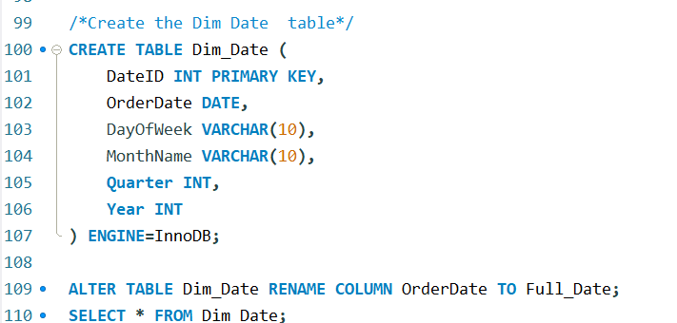
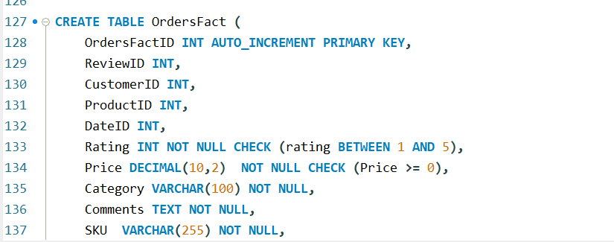
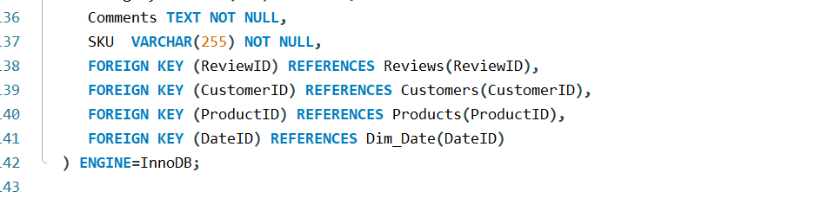
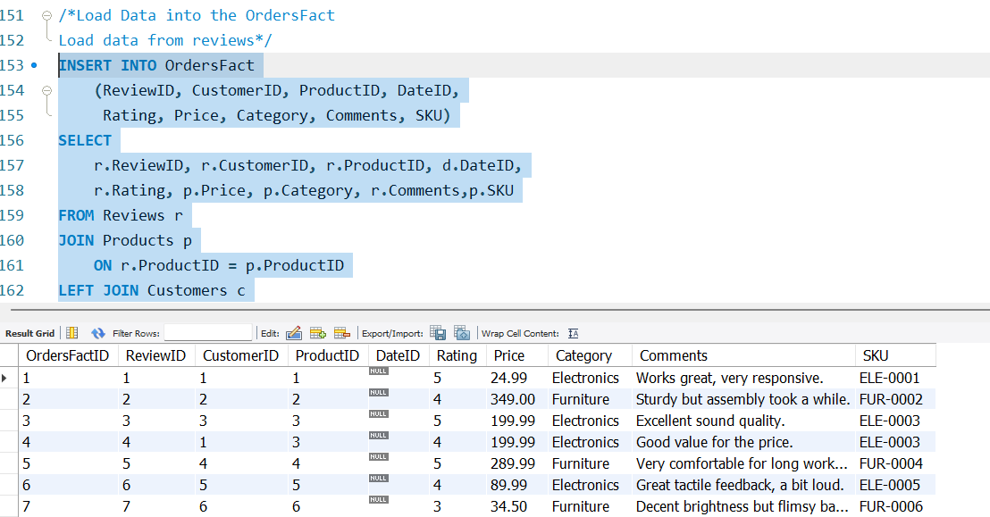
Part 2: Data Integration
- Stage first. Create one staging table per source with every column typed as text, then validate on the way into your final tables. A rating of 6 aborts a load into a typed column; in a text column it waits until your cleaning logic decides. Loading straight into final tables is the most common way this assignment goes wrong.
- Load the CSV (customer_survey.csv) with LOAD DATA LOCAL INFILE.
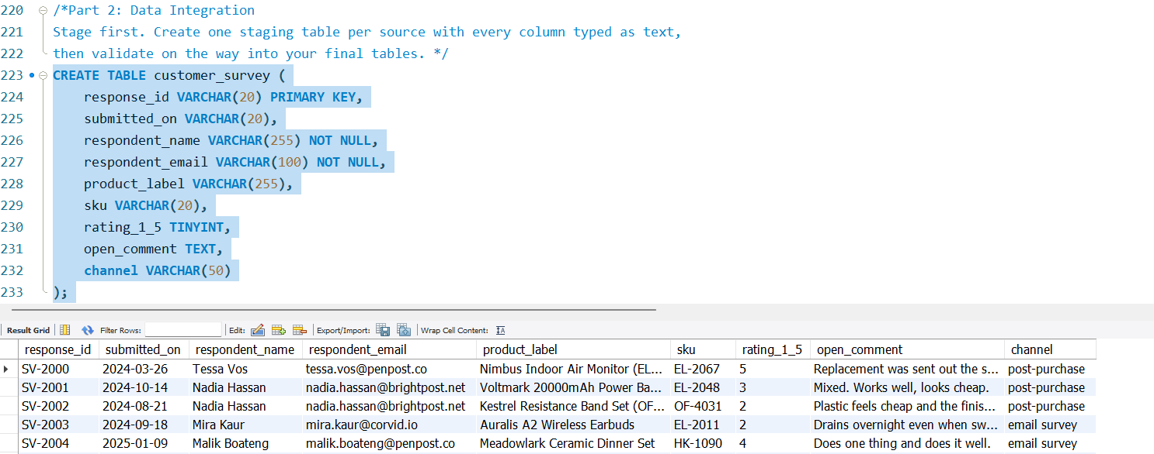
- Load the JSON (web_feedback.json). It is one object containing an array, so a line-by-line load will not work. Use JSON_TABLE or a Python parser. Watch for a field that is sometimes absent rather than empty, and a field whose type varies between records.
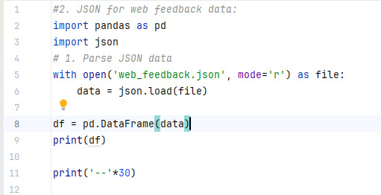
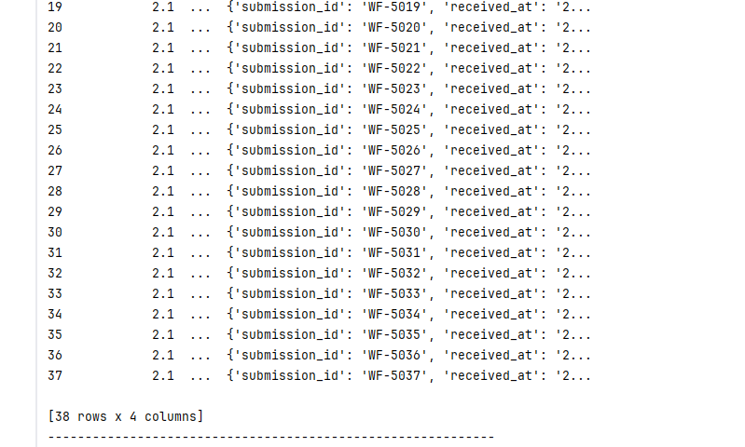
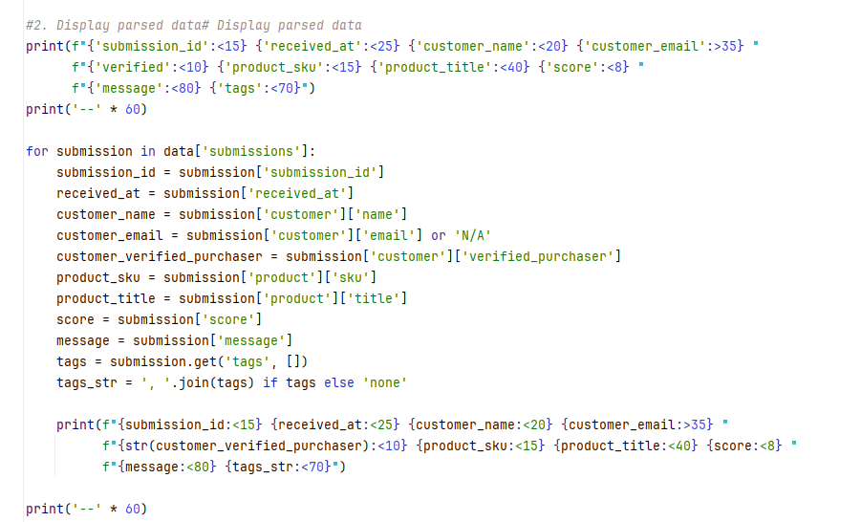
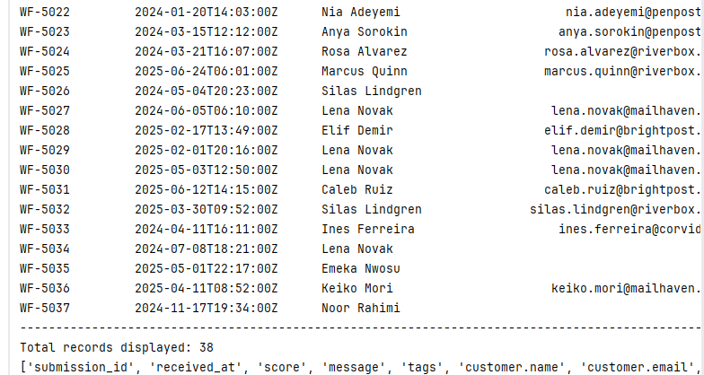
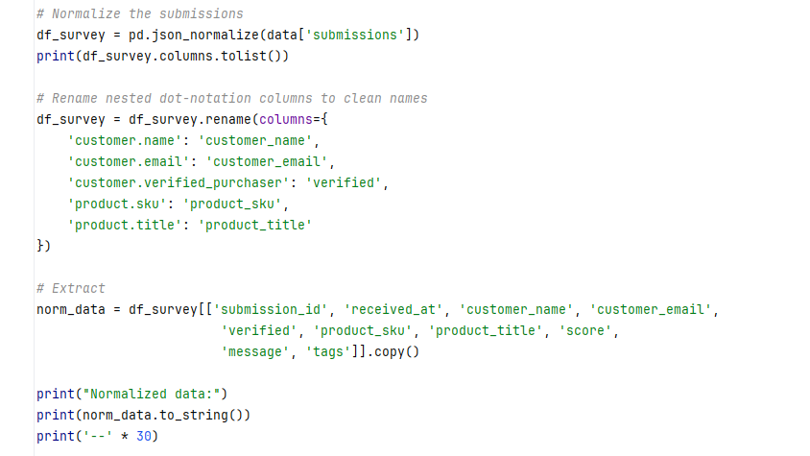
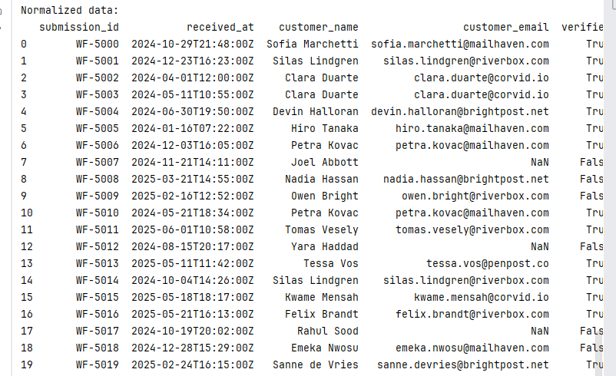
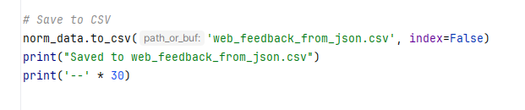
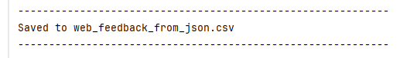
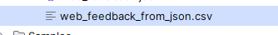
Parse the JSON file after fetch from Python
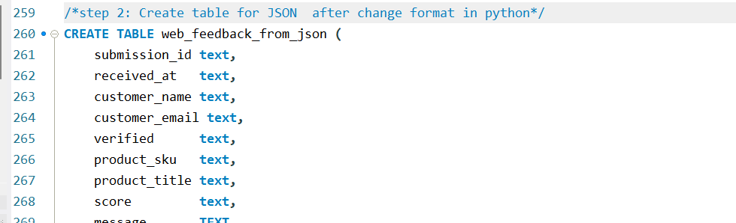
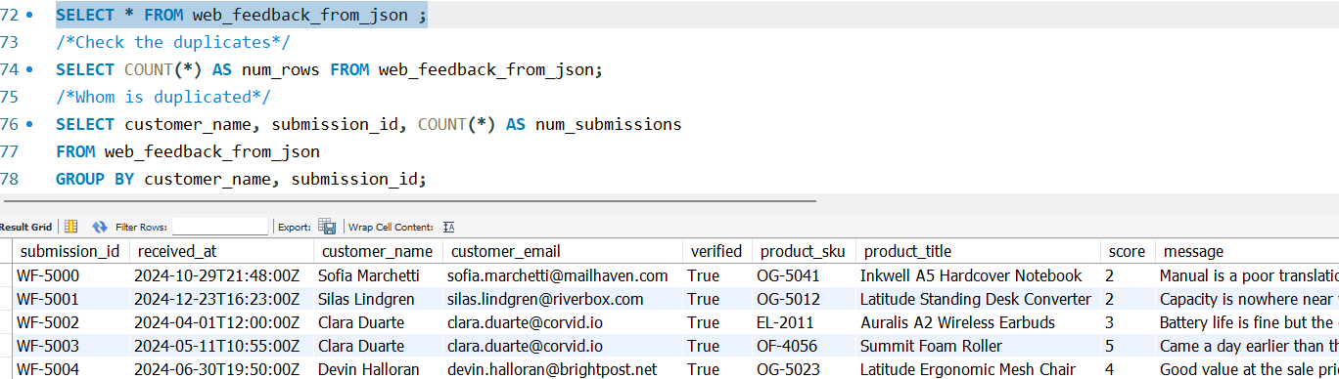
- Load the XML (external_reviews.xml). Try LOAD XML INFILE first, then explain in your report what it could and could not read from this file — the answer depends on where the data physically sits. A Python parser using xml.etree.ElementTree is acceptable if you can say why it was needed.
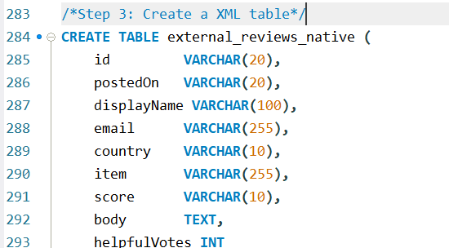
After multiple errors with the system mentioned I need to remove the security mode.
In this case I applied and extra step because I cannot fectch the data until the remove the private mode, I call the cmd in the shell and write the address into it.
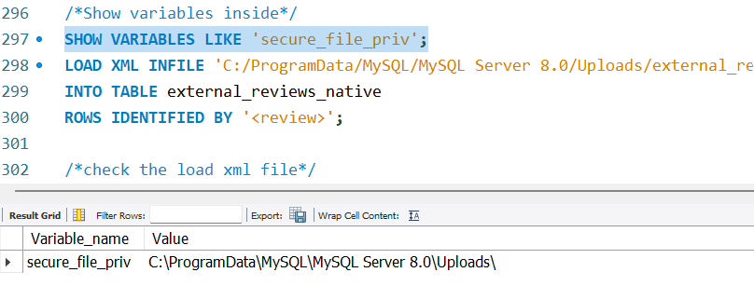
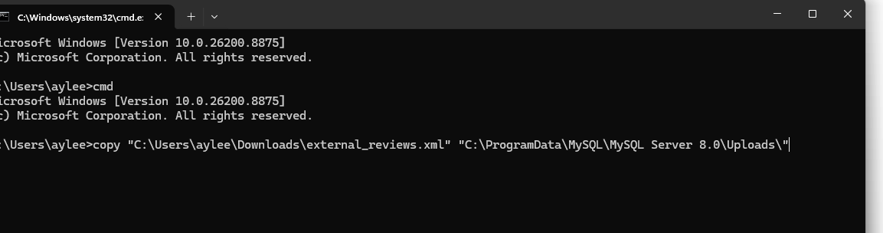
And after that the system shows me 1 file copied.
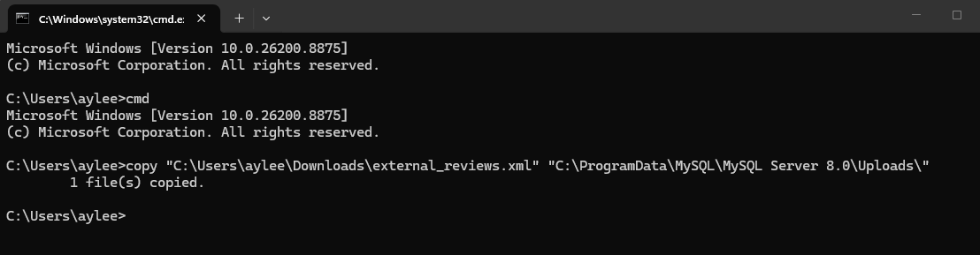
And after that write again the below statement.
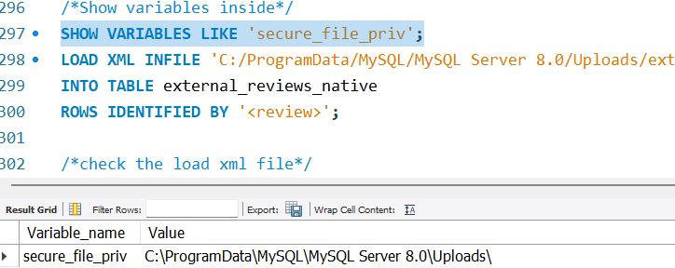
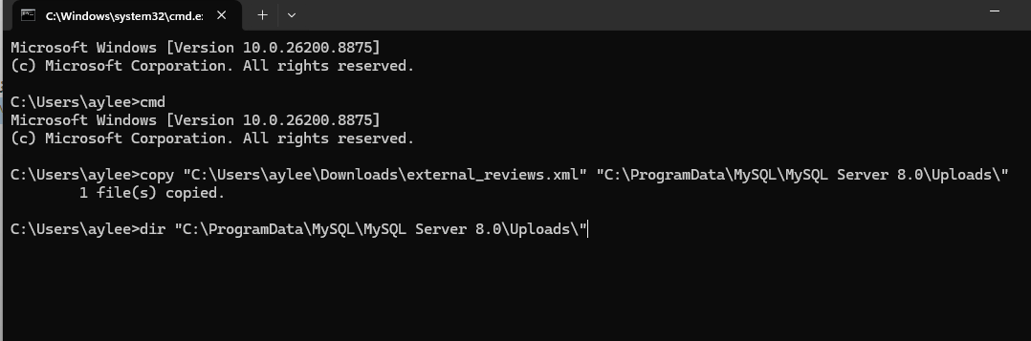
And the system recognized the XML file ‘external_reviews.xml. Now I able to run the ‘Load XML INFILE’.
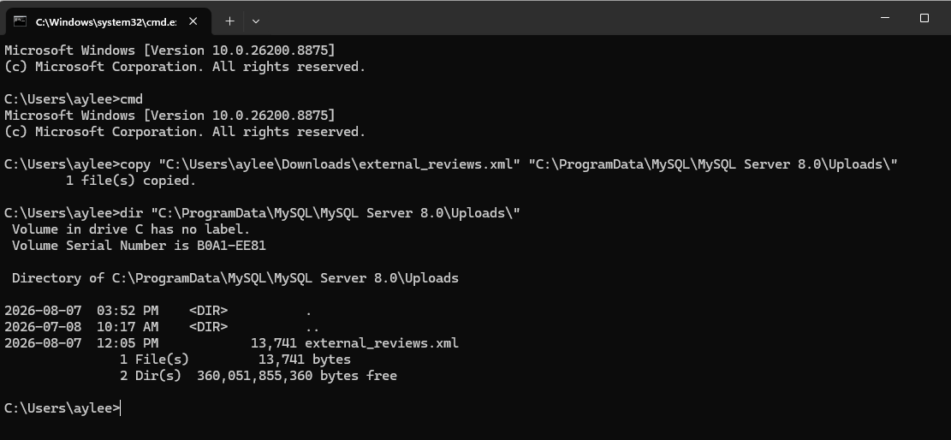
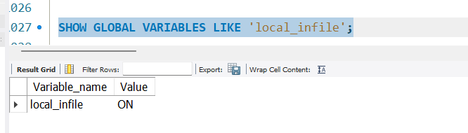
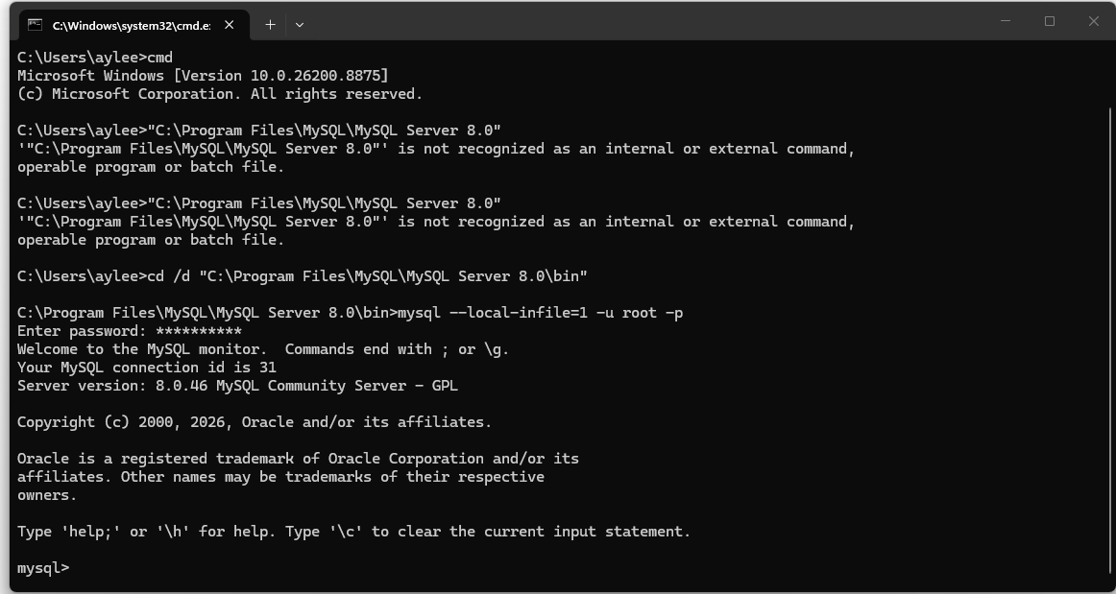
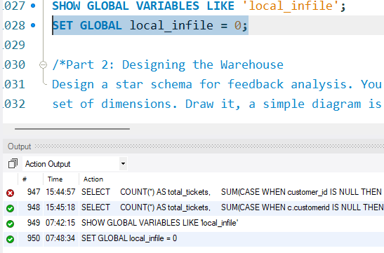
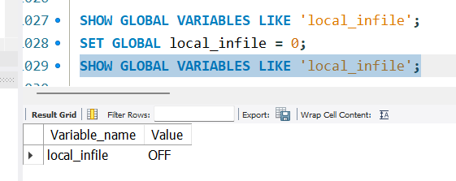
And after all these processes I can load xml file and run.
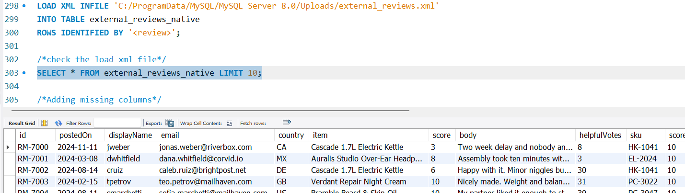
- Clean with UPDATE statements, each one separate and commented. At minimum, handle: inconsistent case and whitespace, a column containing two date formats, ratings outside the valid range, a rating scale that differs from the other feeds, and duplicate submissions.
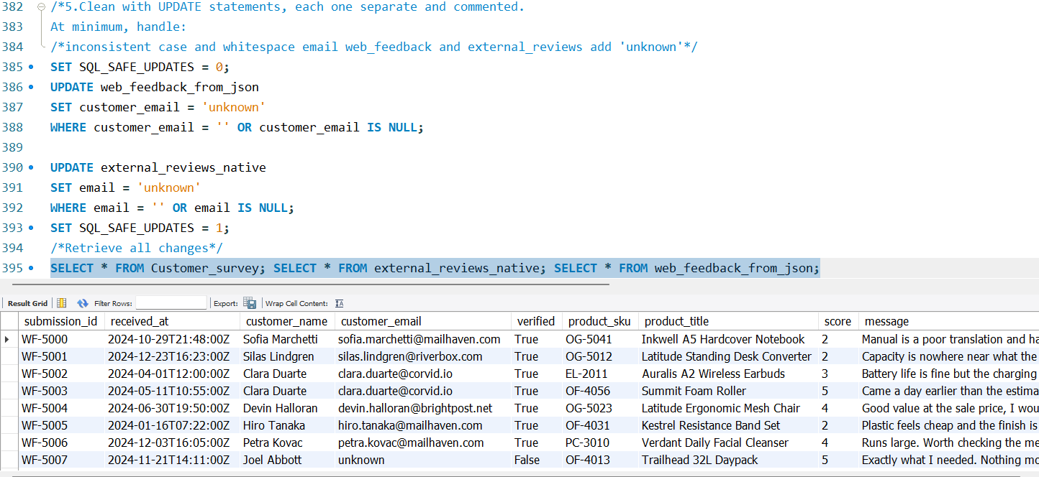
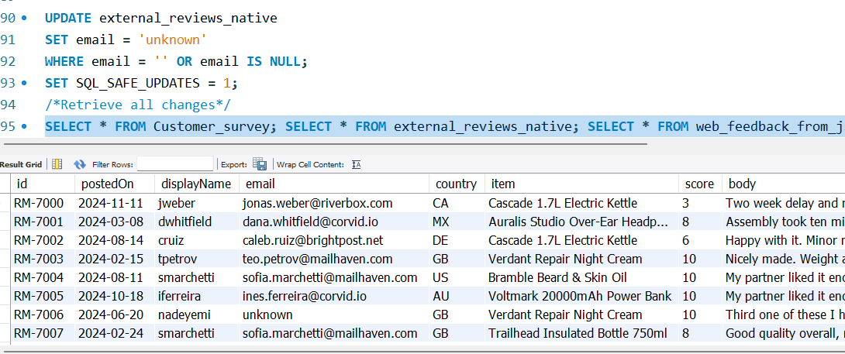
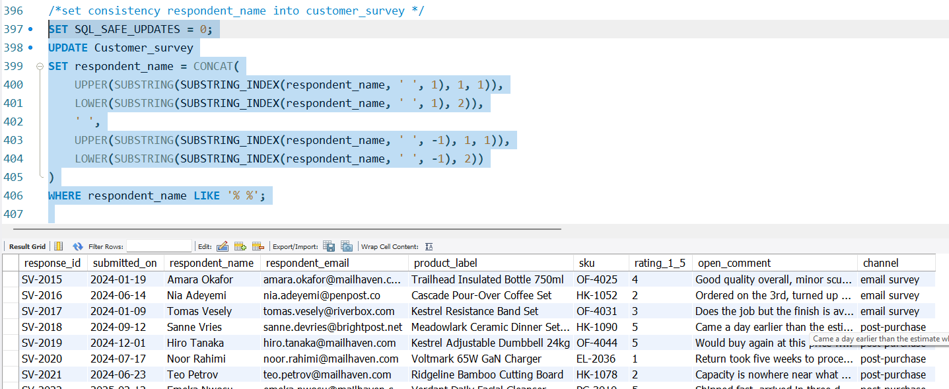
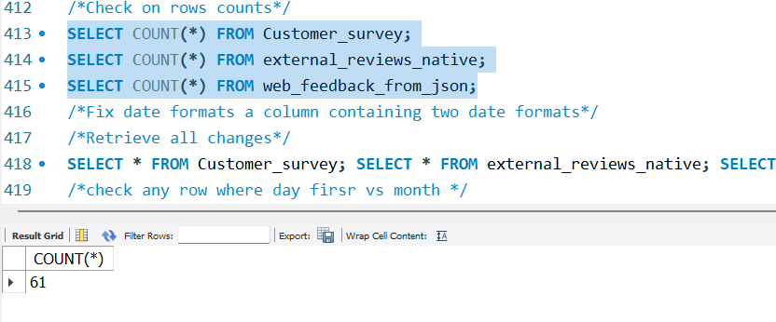
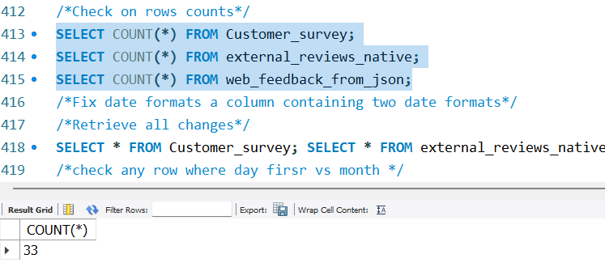
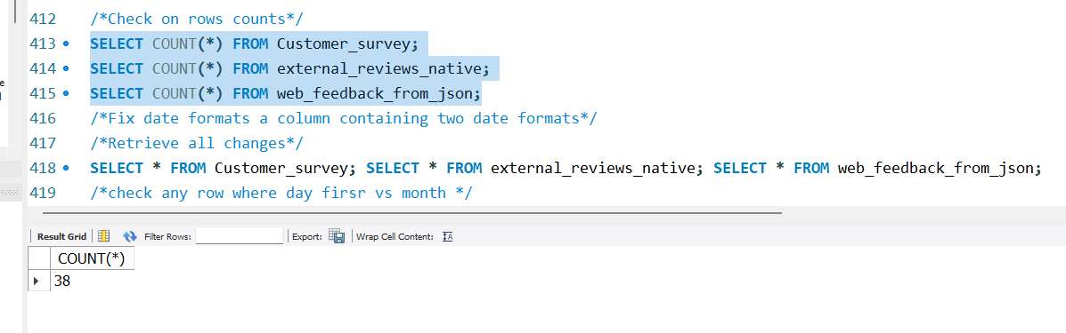
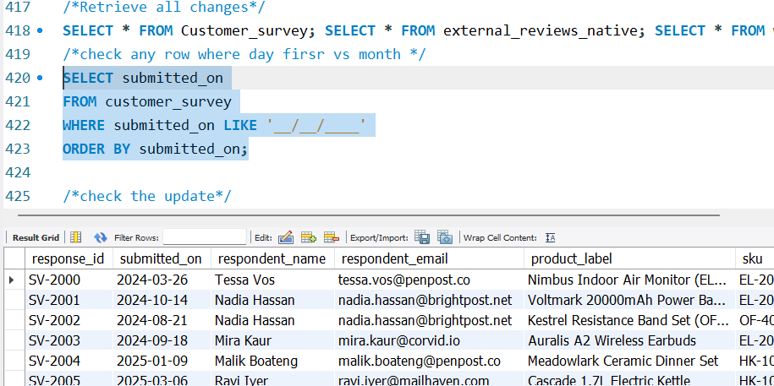
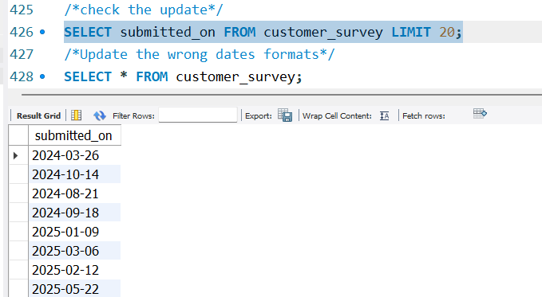
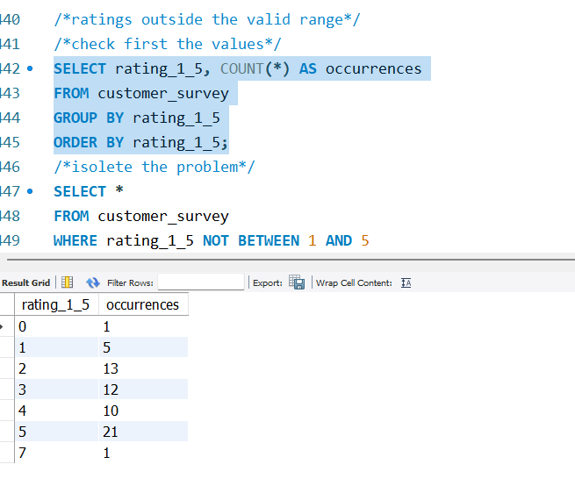
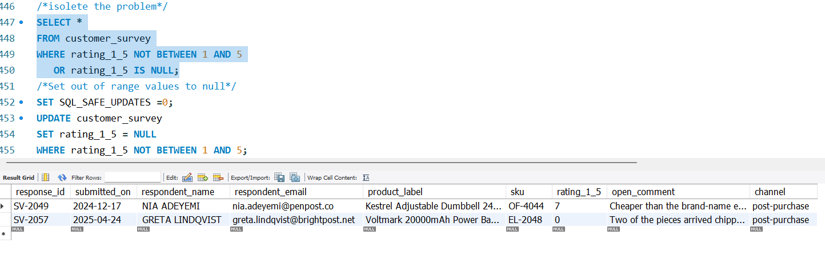

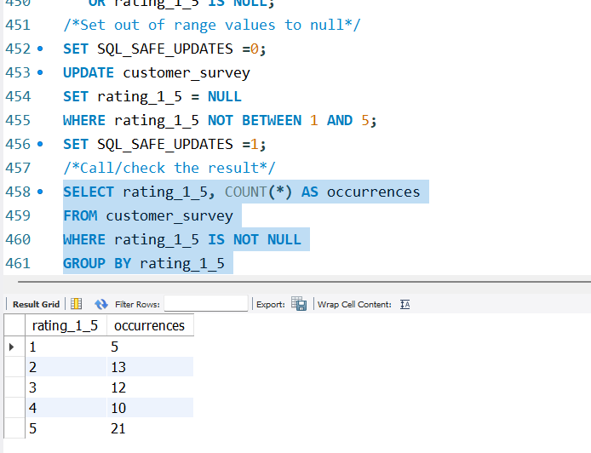
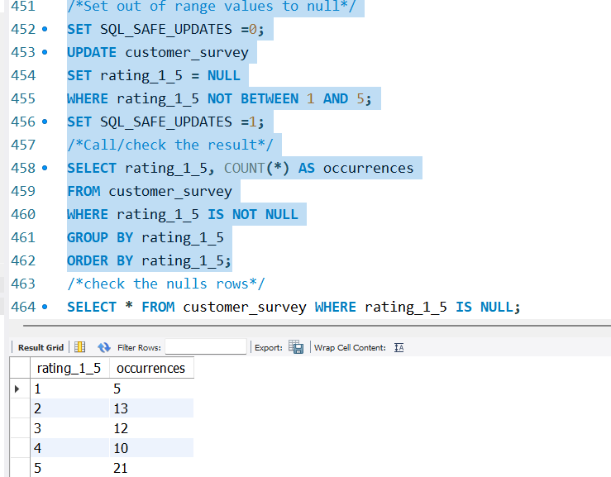
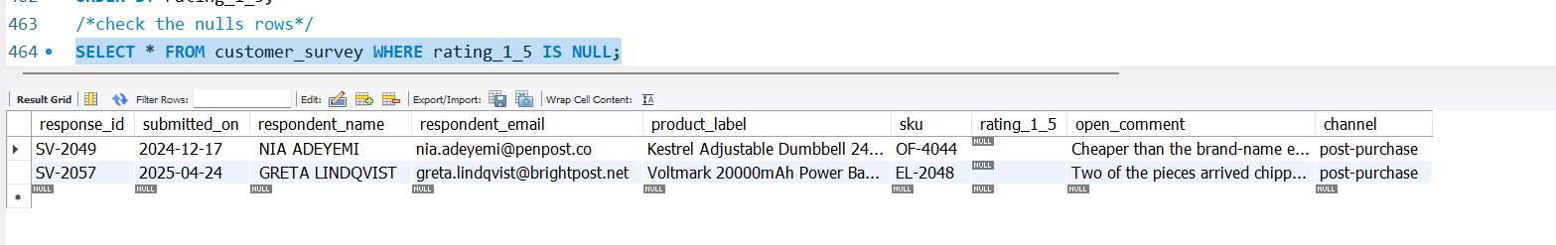
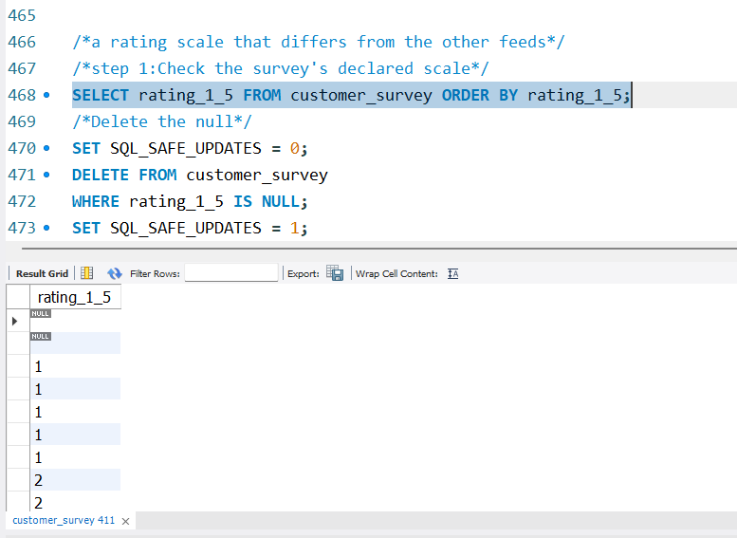
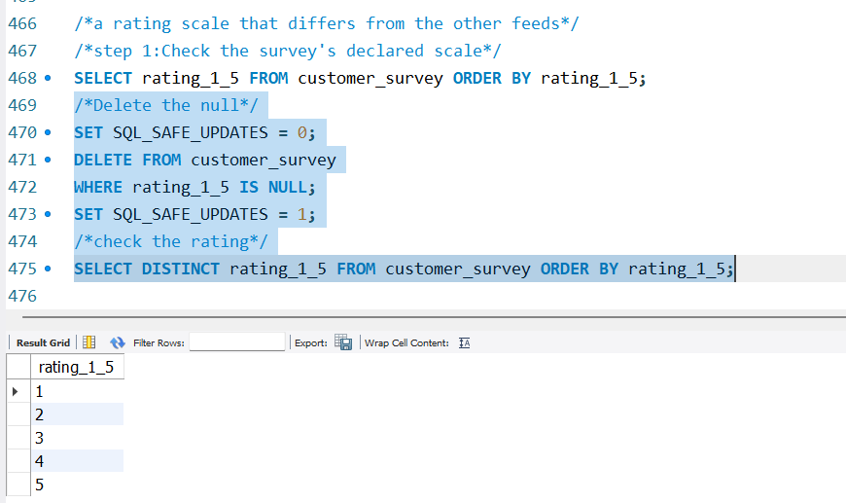

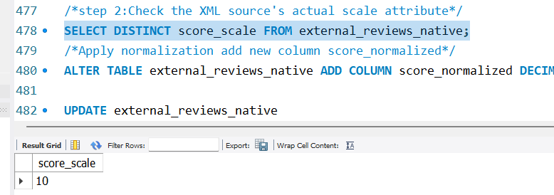
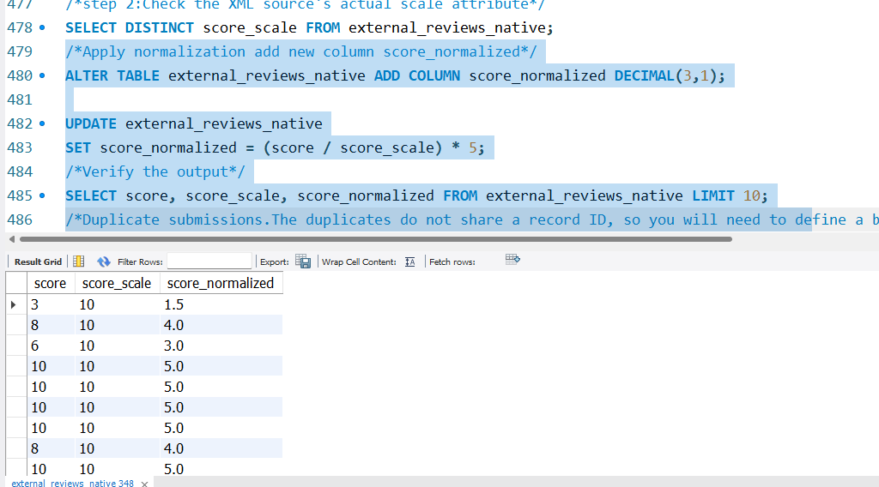
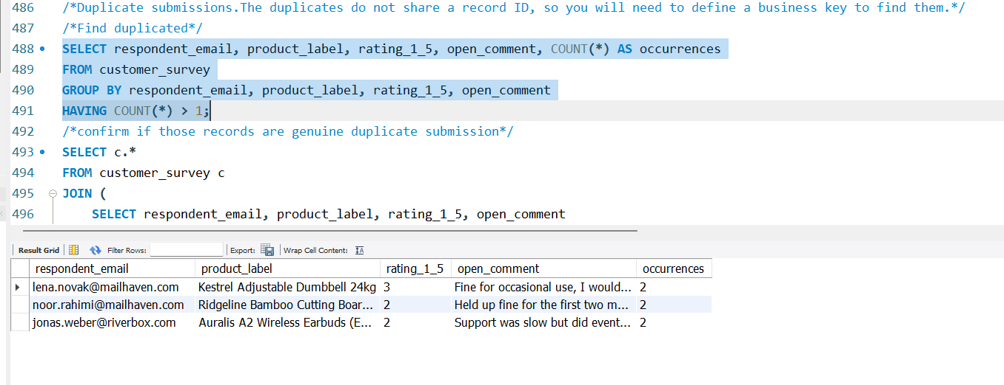
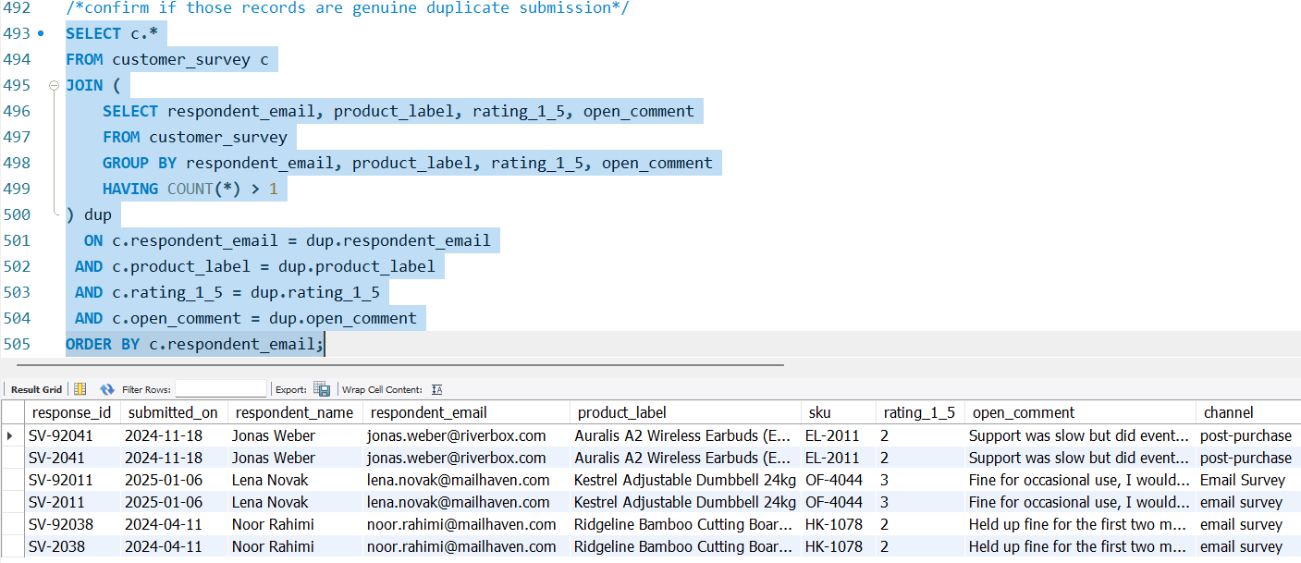
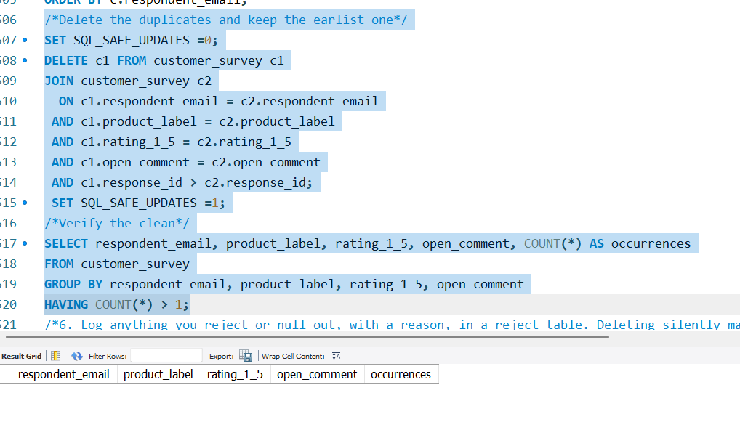
The duplicates do not share a record ID, so you will need to define a business key to find them.
- Log anything you reject or null out, with a reason, in a reject table. Deleting silently makes your row counts impossible to reconcile.
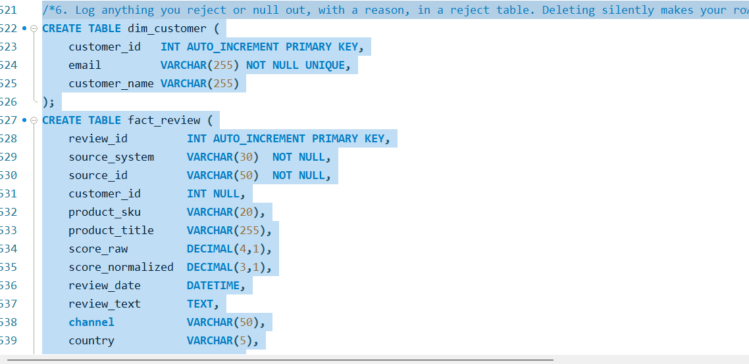
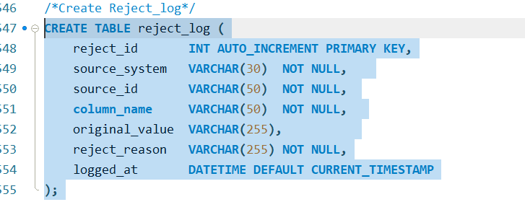
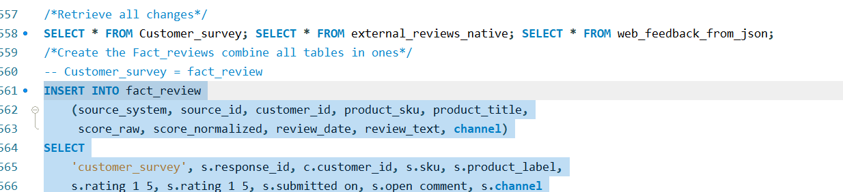
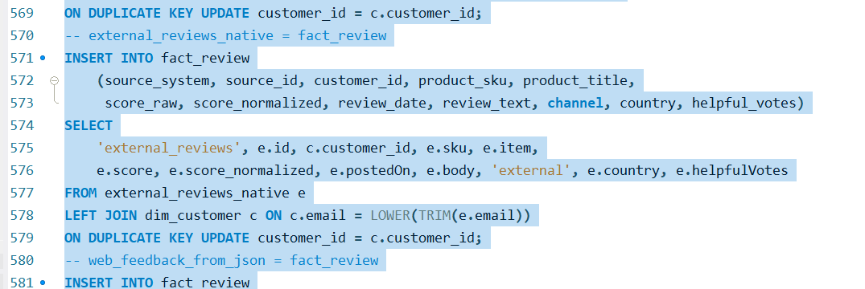
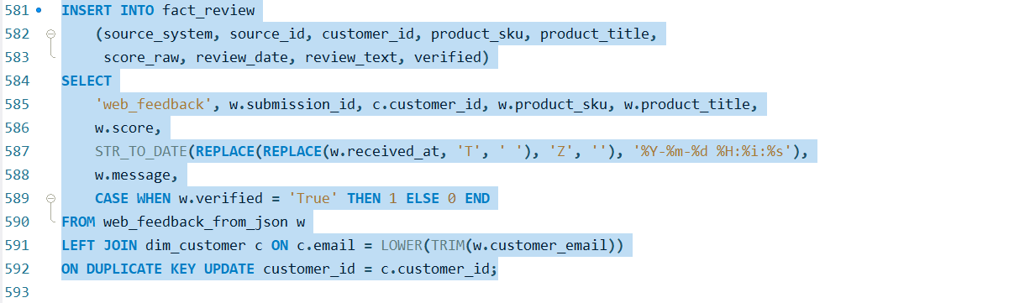
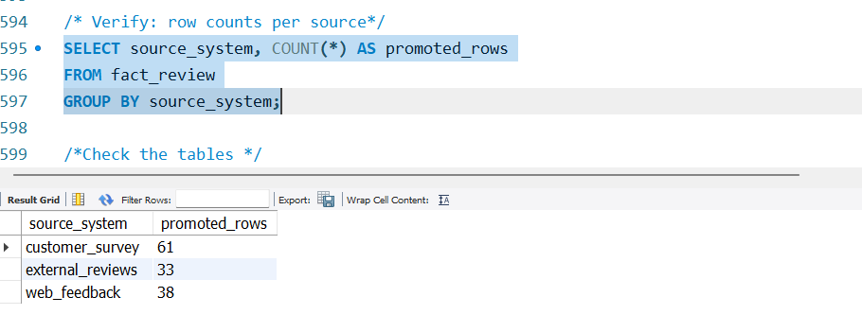
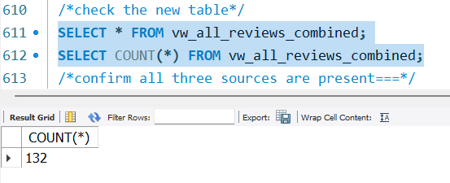

- Promote staging into your final tables. Reviews with no matching customer must still load.
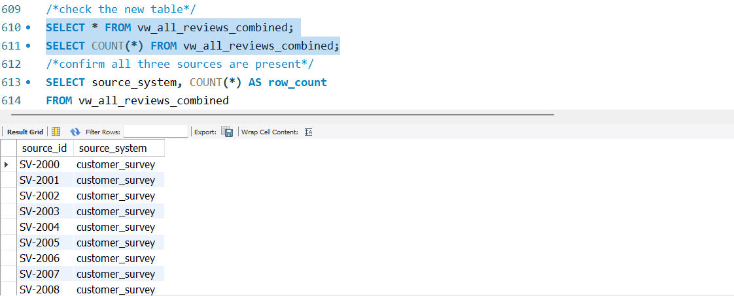

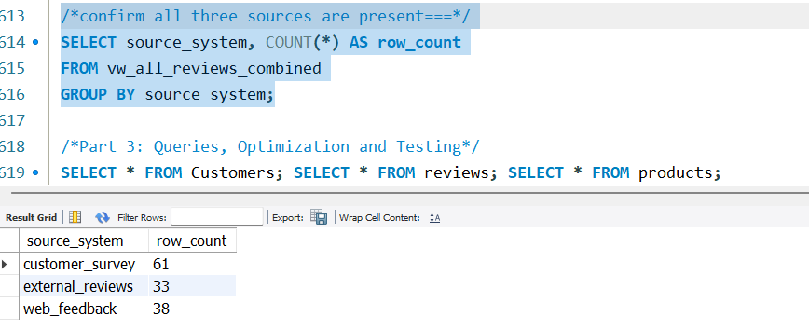
Part 3: Queries, Optimization and Testing
- Create a combined view that joins customer, product, and review data. Use LEFT JOIN where a relationship may be missing, so no review drops out because it has no customer. Check it: the view must return the same row count as the review table.
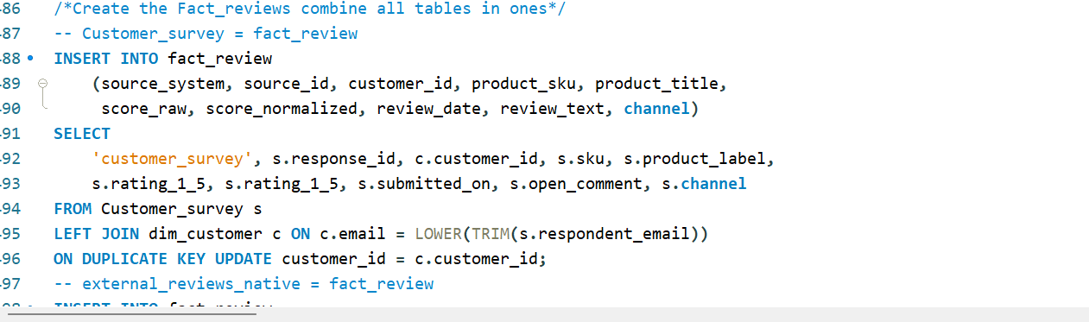
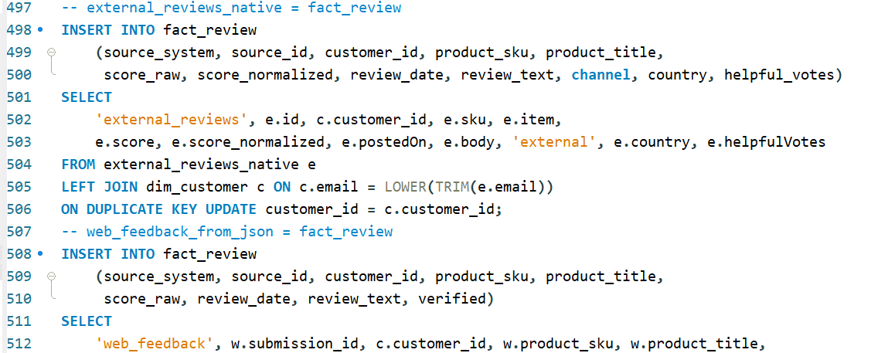
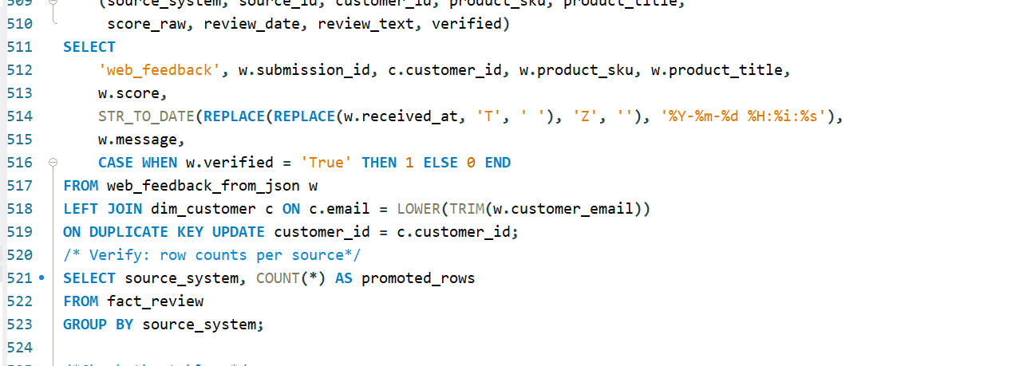
- Write the analysis queries using. WHERE, GROUP BY, HAVING and ORDER BY:
  - Top products by rating and sales. Ranking on raw AVG(rating) puts a two-review product on top; address this with a review threshold or a weighted score.
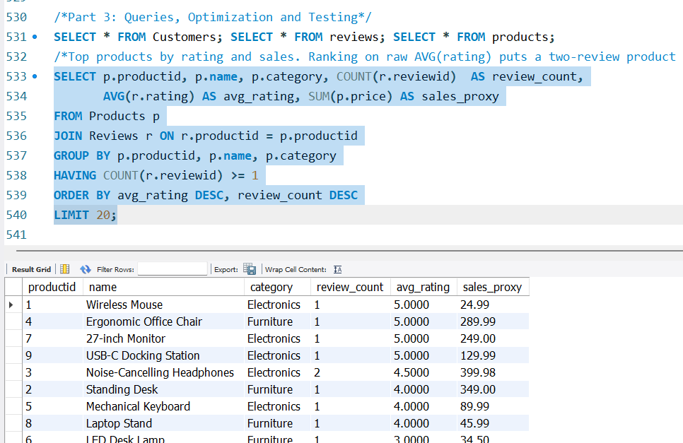
  - Recurring issues, grouped into categories. Store the keyword mapping as data in a table, not as a hard-coded CASE chain.
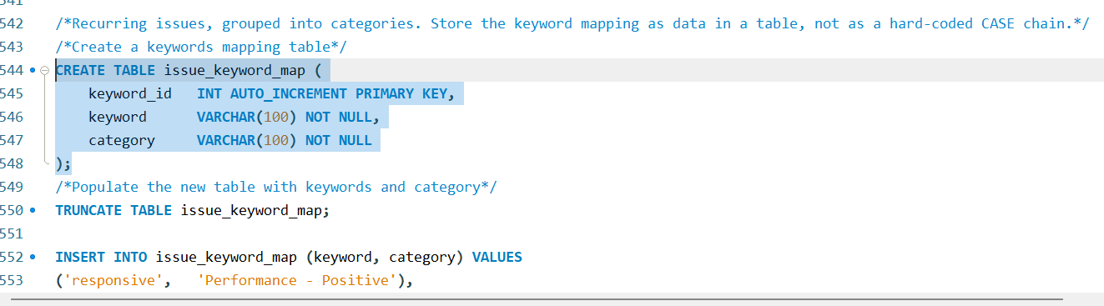
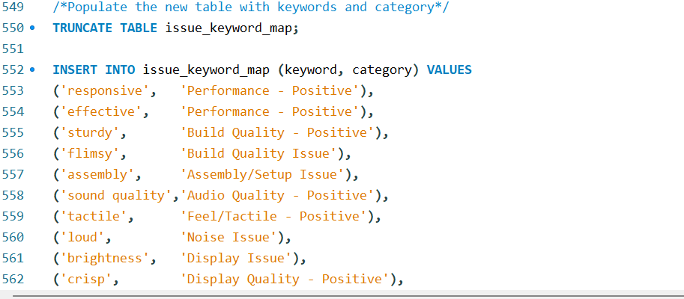
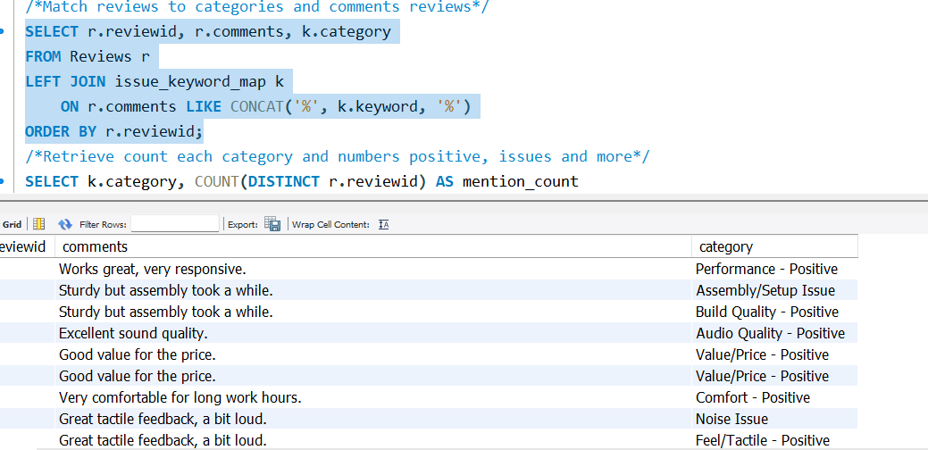
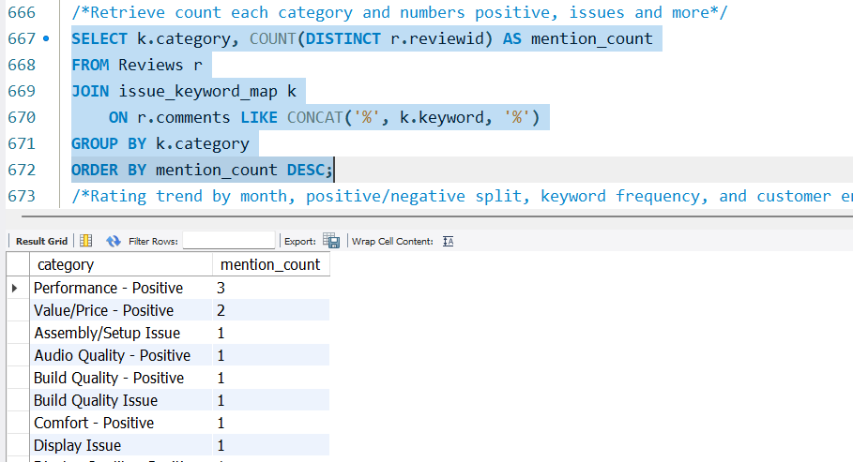

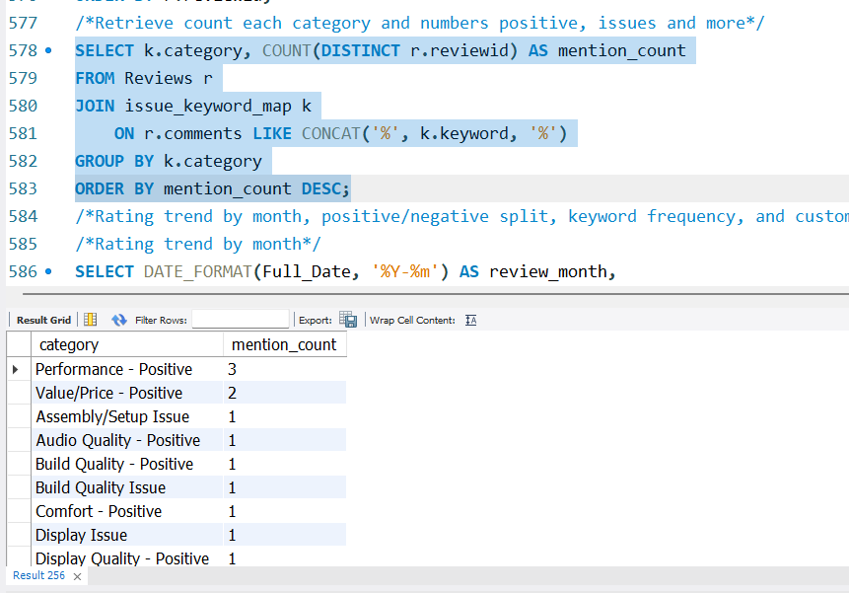
  - Rating trend by month, positive/negative split, keyword frequency, and customer engagement by region.
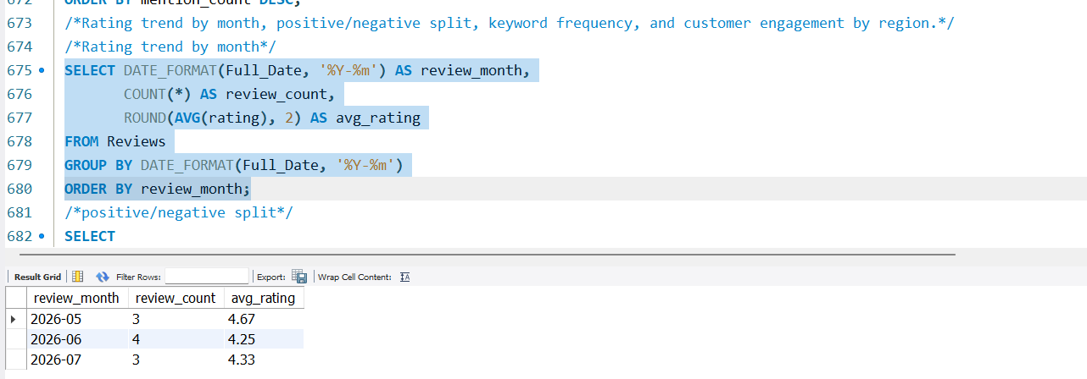
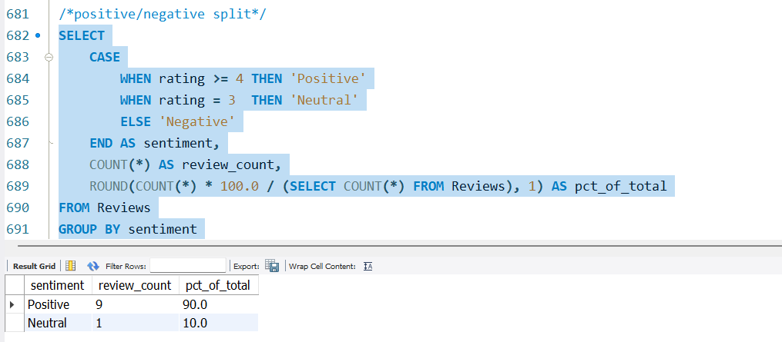
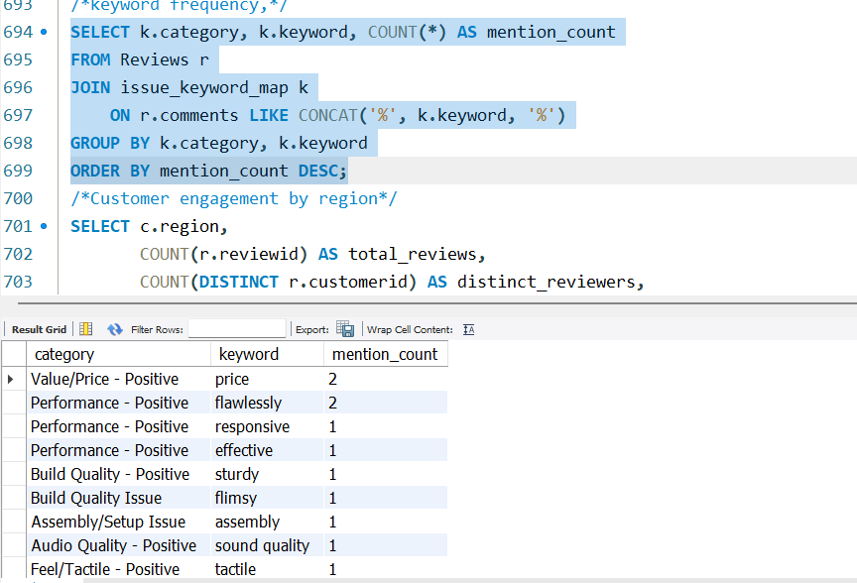
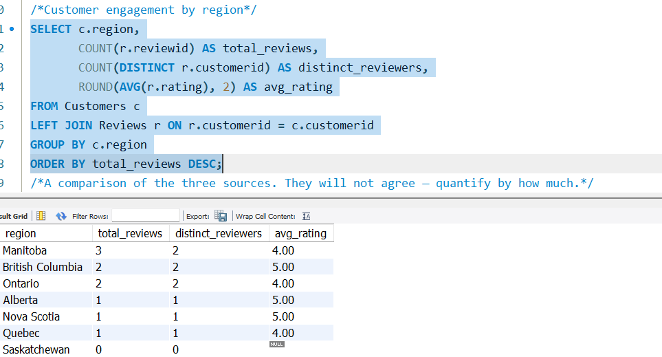
  - A comparison of the three sources. They will not agree — quantify by how much.
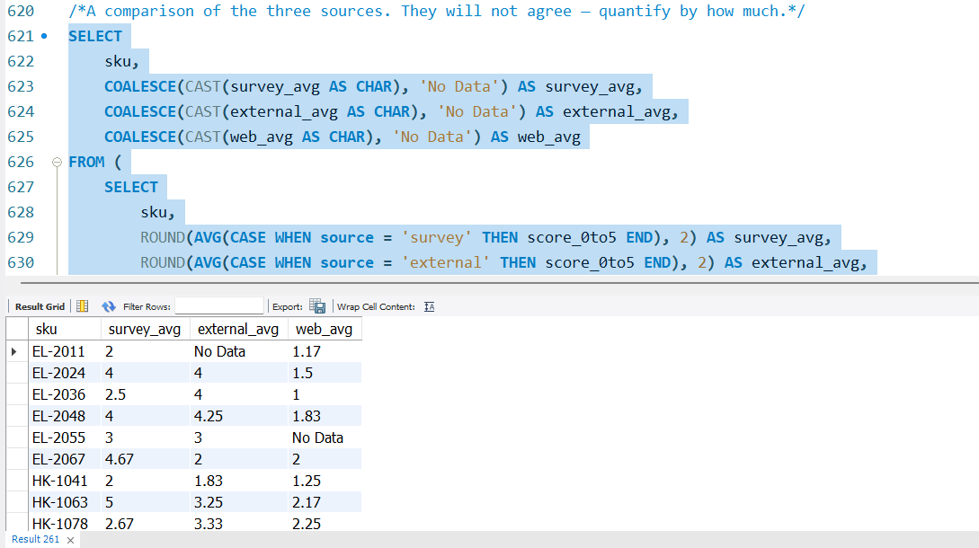
Watch for this: reviews and sales sit at different grains. Joining both to the product table at once multiplies revenue by the review count.
- Create two views: top-rated products, and flagged reviews. Define "flagged" yourself and justify the threshold.
Definition f “Flagged” a review is flagged if either of two conditions are true: example Low rating (1 or 2) and Negative keyword example(build quality issue, assembly/issue, etc).
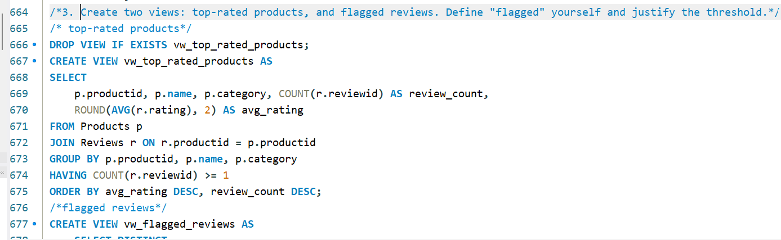
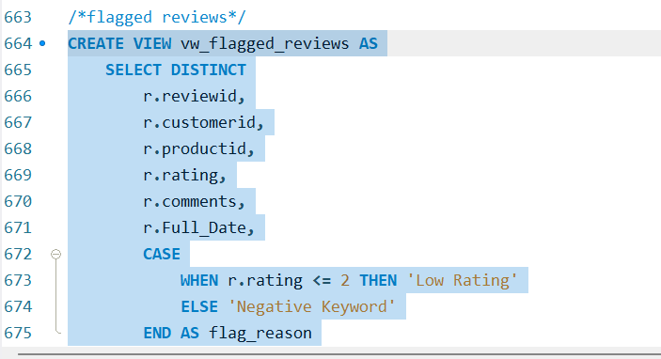
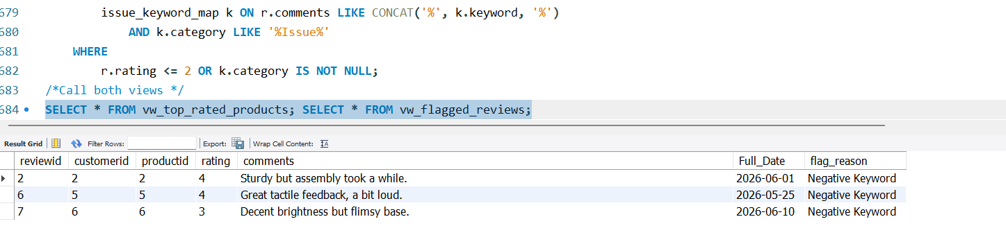
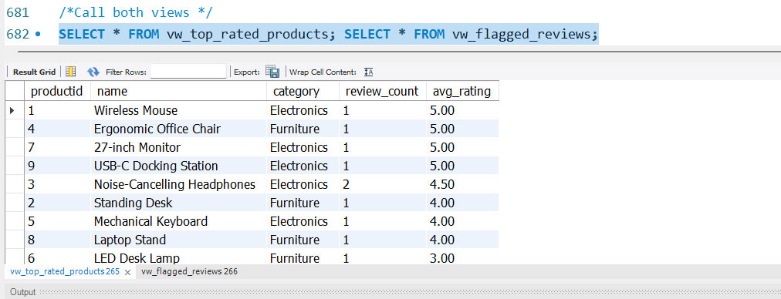
- Add indexes only where a query you wrote needs one, and name the query each serves. Create them after the bulk load and explain why the order matters. Run EXPLAIN before and after, and paste both into your report.
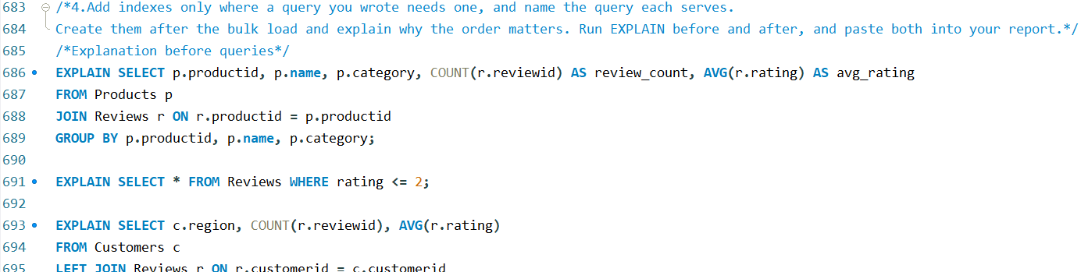
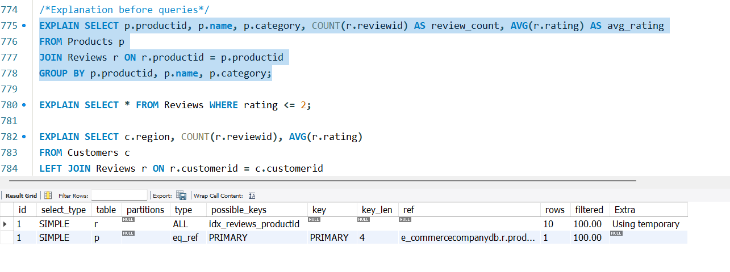
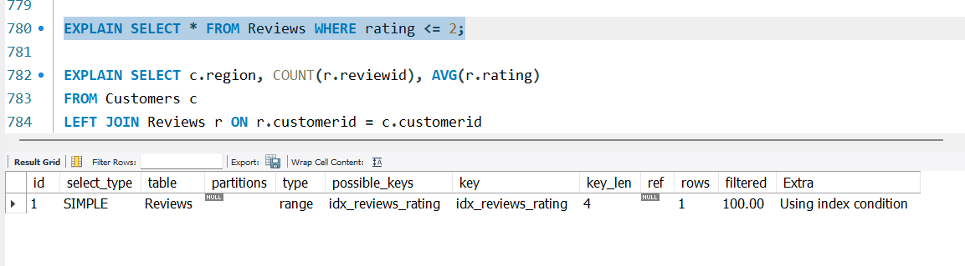
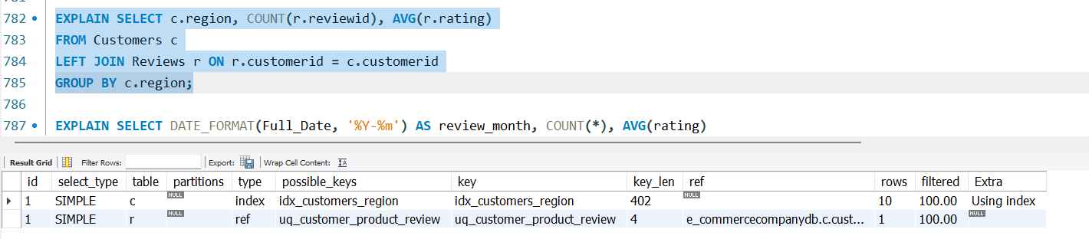
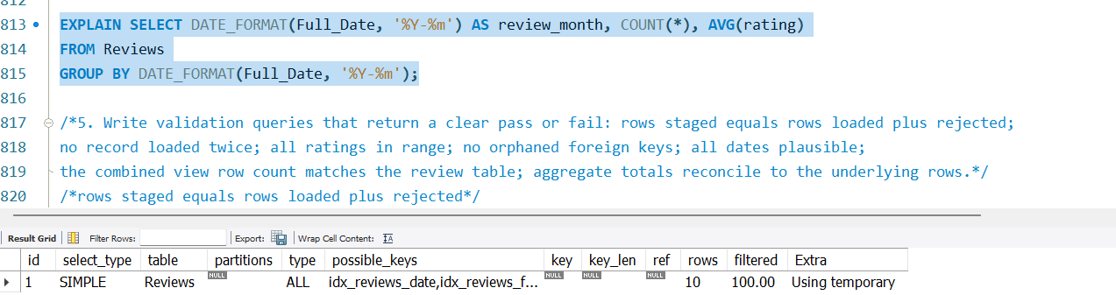
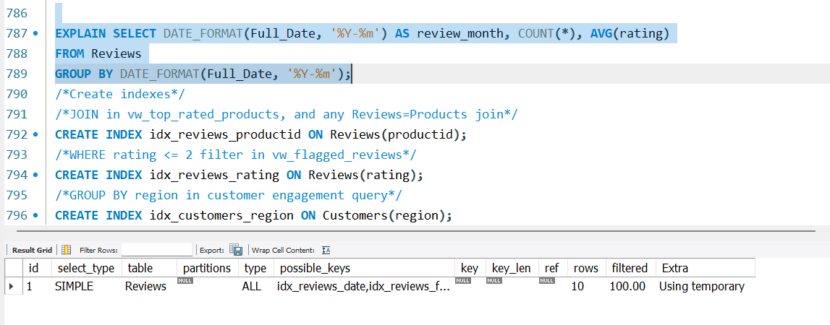
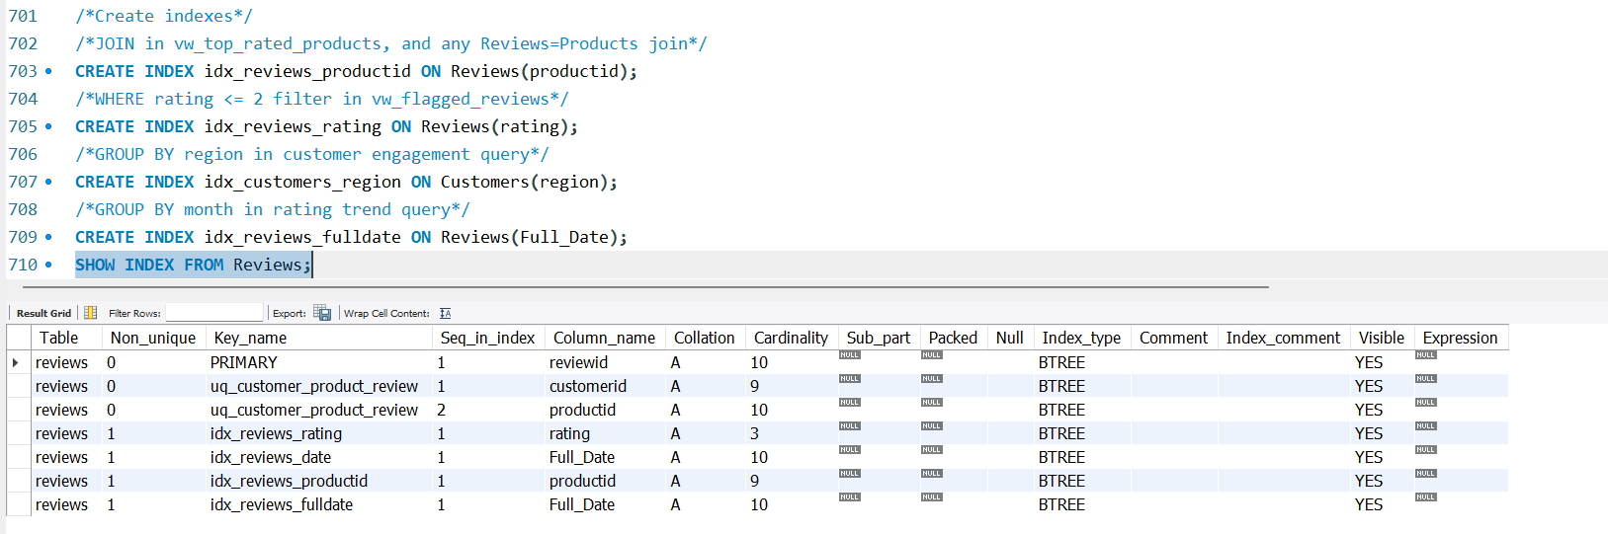
This dataset is small enough that the optimizer may correctly ignore your index. If that happens, say so and explain what changes at scale. An honest "no measurable improvement" scores better than an invented speedup.

- Write validation queries that return a clear pass or fail: rows staged equals rows loaded plus rejected; no record loaded twice; all ratings in range; no orphaned foreign keys; all dates plausible; the combined view row count matches the review table; aggregate totals reconcile to the underlying rows.
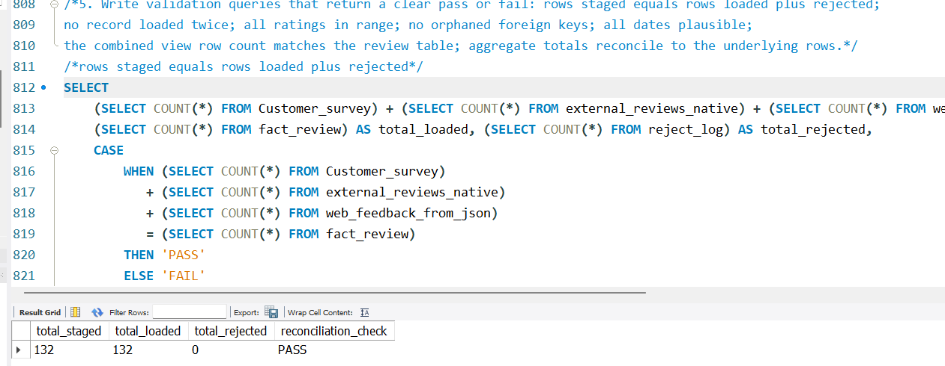
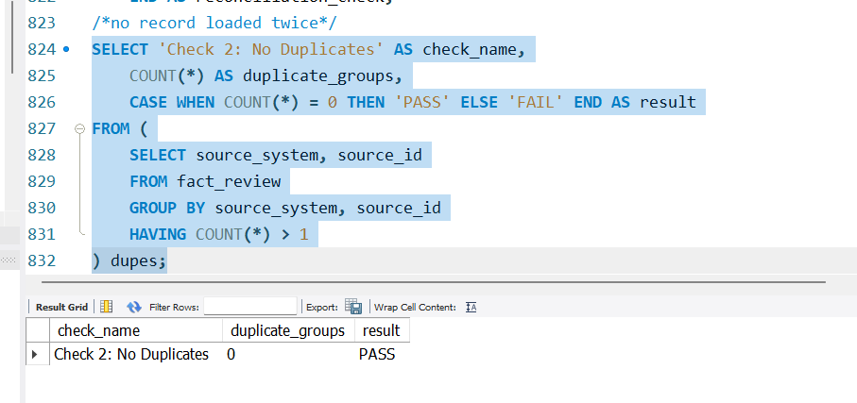
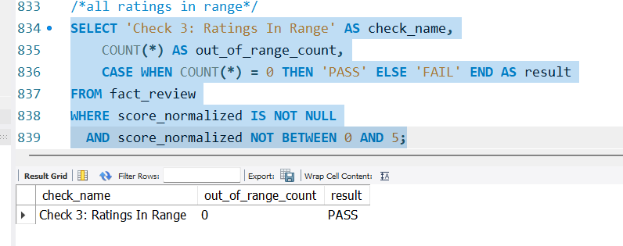
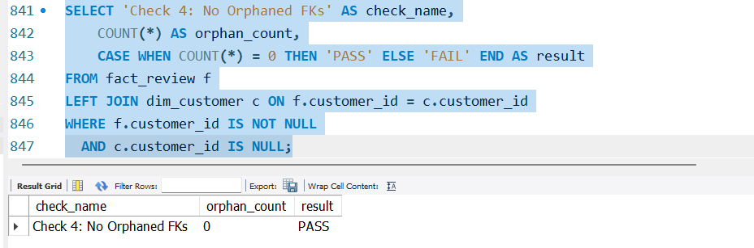
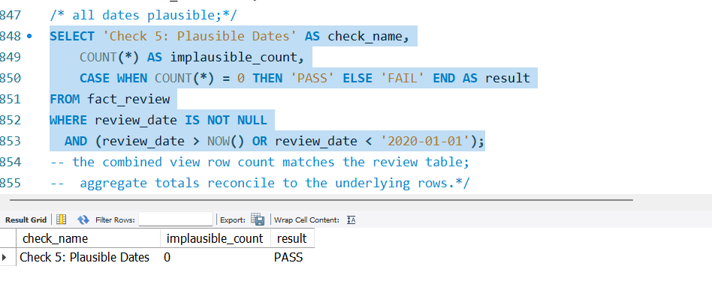
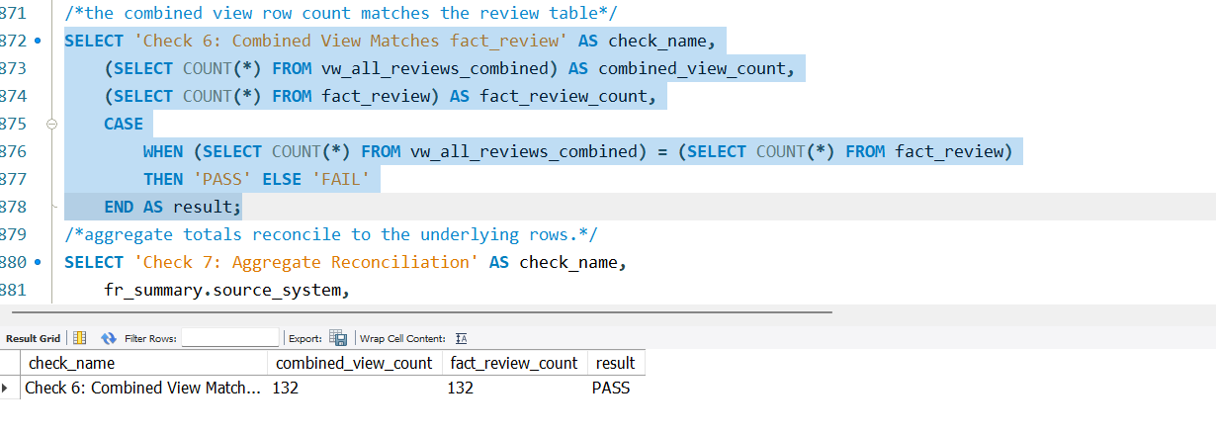
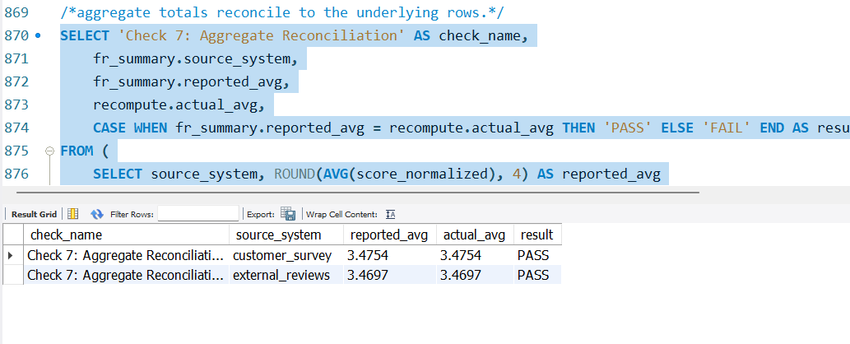

- Optional, for bonus marks: a stored procedure that promotes staging to final tables inside a transaction with an error handler, or a stored function that centralizes a definition such as a rating band.
Deliverables
Submit one archive named lastname_firstname_finalproject.zip containing:
- ER diagram (PNG or PDF) showing all tables, keys and cardinality.
- SQL scripts, numbered so that running them in filename order rebuilds your database from nothing.
- Parsing scripts for CSV, JSON and XML, commented and runnable from the command line.
- Report (PDF or Word, 1,200–2,000 words plus tables) covering: design decisions and why; a data quality log with row counts per defect; your XML justification from Part 2.4; index strategy with EXPLAIN output; validation results; findings for the three objectives; and a limitations section stating what your analysis cannot support.
- README – how to run everything, in order.

